**Supplementary Figure 2. Funnel plots (random (A) and fixed (B) effects models) regarding COVID-19 as a risk factor for GDM.** COVID-19, coronavirus disease 2019.

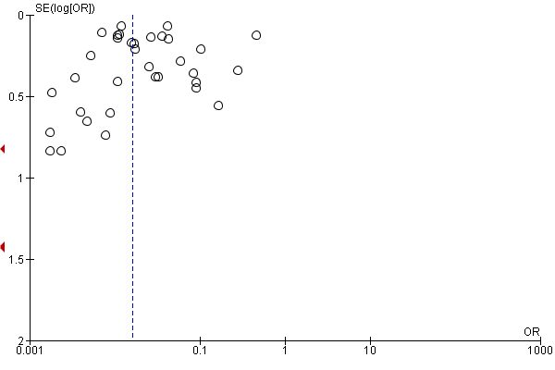

Fig. 2.A

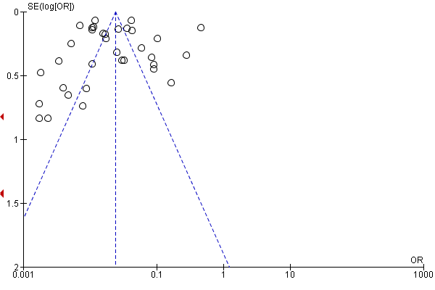

Fig. 2.B