Supplementary Material 2

Table 1. Studies Truly Representative and With a Justified Sample Size According to the Newcastle-Ottawa Scale
Studies (first author) | Representativeness | Sample size | Non-response rate | Assessment of the outcome | Statistical test
Amouzegar (1996) [1] | A | A | B | C | A
Hadaegh (2006) [2] | A | A | A | C | A
Lee (2007) [3] | A | A | A | C | A
Jia (2007) [4] | A | A | A | C | A
Moazzami (2009) [5] | A | A | A | C | A
Wang (2009) [6] | A | A | C | C | A
Suliga (2010) [7] | A | A | A | C | A
Benziger (2010) [8] | A | A | A | C | A
Perini (2011) [9] | A | A | C | C | A
Zhu (2017) [10] | A | A | A | C | A

Table 2. Other Criteria Used to Define Metabolic Alterations
 | Lee [3] | Kim [11] | Buscemi [12]
Absolutely required | None | None | None
Criteria | At least 1 | At least 1 | At least 2
Blood pressure | ≥ 140/90 mm Hg | ≥ 130/85 mm Hg | ≥ 130/85 mm Hg
Fasting triglycerides | - | ≥ 150 mg/dL | ≥ 150 mg/dL
High-density lipoprotein (HDL) cholesterol | - | < 40 mg/dL (men)  < 50 mg/dL (women) | < 40 mg/dL (men)  < 50 mg/dL (women)
Total cholesterol | ≥ 240 mg/dL | - | > 200 mg/dL
Higher fasting blood sugar | ≥ 126 mg/dL | ≥ 100 mg/dL | -
Other | HOMA-IR score ≥ 2.5 | Ultrasound-based presence of fatty liver

Figure 1. Forest plot of the prevalence of all the studies.
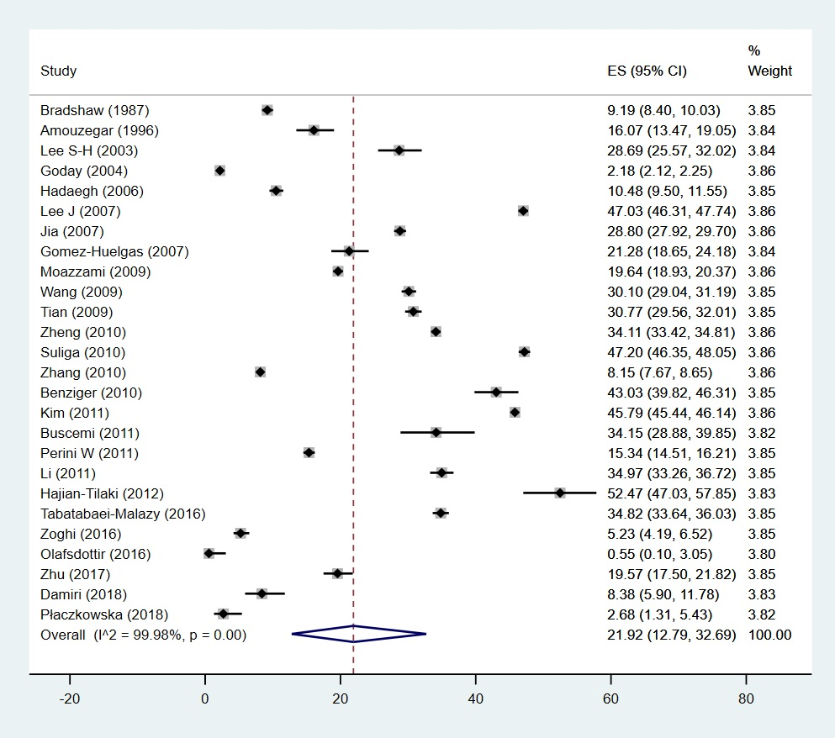

References
1. Amouzegar A, Kazemian E, Abdi H, Mansournia MA, Bakhtiyari M, Hosseini MS, et al. Association Between Thyroid Function and Development of Different Obesity Phenotypes in Euthyroid Adults: A Nine-Year Follow-Up. Thyroid. 2018;28(4):458–64. doi:10.1089/thy.2017.0454
2. Hadaegh F, Zabetian A, Harati H, Azizi F. Metabolic syndrome in normal-weight Iranian adults. Ann Saudi Med. 2007;27(1):18–24. doi:10.5144/0256-4947.2007.18
3. Lee S-H, Ha H-S, Park Y-J, Lee J-H, Yim H-W, Yoon K-H, et al. Identifying metabolically obese but normal-weight (MONW) individuals in a nondiabetic Korean population: the Chungju Metabolic disease Cohort (CMC) study. Clin Endocrinol (Oxf). 2011;75(4):475–81. doi:10.1111/j.1365-2265.2011.04085.x
4. Jia A, Xu S, Xing Y, Zhang W, Yu X, Zhao Y, et al. Prevalence and cardiometabolic risks of normal weight obesity in Chinese population: A nationwide study. Nutr Metab Cardiovasc Dis. 2018;28(10):1045–53. doi:10.1016/j.numecd.2018.06.015
5. Moazzami K, Lima BB, Sullivan S, Shah A, Bremner JD, Vaccarino V. Independent and joint association of obesity and metabolic syndrome with depression and inflammation. Health Psychol. 2019;38(7):586–95. doi:10.1037/hea0000764
6. Wang B, Zhuang R, Luo X, Yin L, Pang C, Feng T, et al. Prevalence of Metabolically Healthy Obese and Metabolically Obese but Normal Weight in Adults Worldwide: A Meta-Analysis. Horm Metab Res. 2015;47(11):839–45. doi:10.1055/s-0035-1559767
7. Suliga E, Kozieł D, Głuszek S. Prevalence of metabolic syndrome in normal weight individuals. Ann Agric Environ Med. 2016;23(4):631–5. doi:10.5604/12321966.1226858
8. Benziger CP, Bernabé-Ortiz A, Gilman RH, Checkley W, Smeeth L, Málaga G, et al. Metabolic Abnormalities Are Common among South American Hispanics Subjects with Normal Weight or Excess Body Weight: The CRONICAS Cohort Study. PLoS One. 2015;10(11):e0138968. doi:10.1371/journal.pone.0138968
9. Perini W, Kunst AE, Snijder MB, Peters RJG, van Valkengoed IGM. Ethnic differences in metabolic cardiovascular risk among normal weight individuals: Implications for cardiovascular risk screening. The HELIUS study. Nutr Metab Cardiovasc Dis. 2019;29(1):15–22. doi:10.1016/j.numecd.2018.09.004
10. Zhu X, Hu J, Guo H, Ji D, Yuan D, Li M, et al. Effect of Metabolic Health and Obesity Phenotype on Risk of Diabetes Mellitus: A Population-Based Longitudinal Study. Diabetes Metab Syndr Obes. 2021;14:3485–98. doi:10.2147/DMSO.S317739
11. Kim M-H, Chang Y, Jung H-S, Shin H, Ryu S. Impact of Self-Rated Health on Progression to a Metabolically Unhealthy Phenotype in Metabolically Healthy Obese and Non-Obese Individuals. J Clin Med. 2019;8(1):34. doi:10.3390/jcm8010034
12. Buscemi S, Chiarello P, Buscemi C, Corleo D, Massenti MF, Barile AM, et al. Characterization of Metabolically Healthy Obese People and Metabolically Unhealthy Normal-Weight People in a General Population Cohort of the ABCD Study. J Diabetes Res. 2017;2017:9294038. doi:10.1155/2017/9294038

