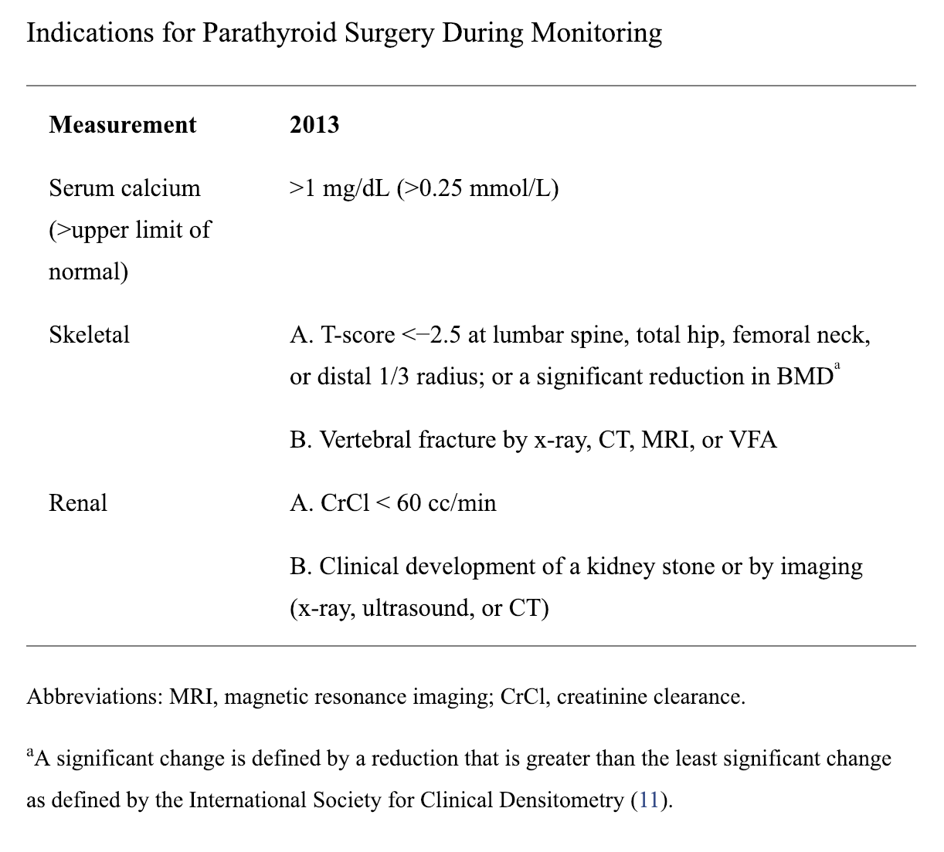

Supplementary figure 1: PHPT elective parathyroidectomy consensus criteria [5]

