**Supplementary Figure 3. Funnel plot (random (A) and fixed (B) effects models) regarding GDM as a risk factor for COVID-19.** COVID-19, coronavirus disease 2019.

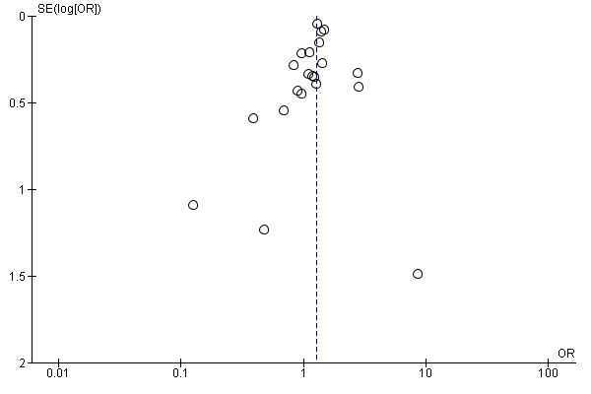

Fig. 3.A

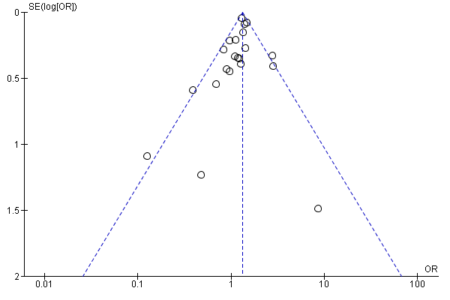

Fig. 3.B